**Practical No. 7**

**Aim:** Web Application using Azure

**Steps:**

Step 1: create a new project search up or select ‘Azure Cloud Service (extended support)’

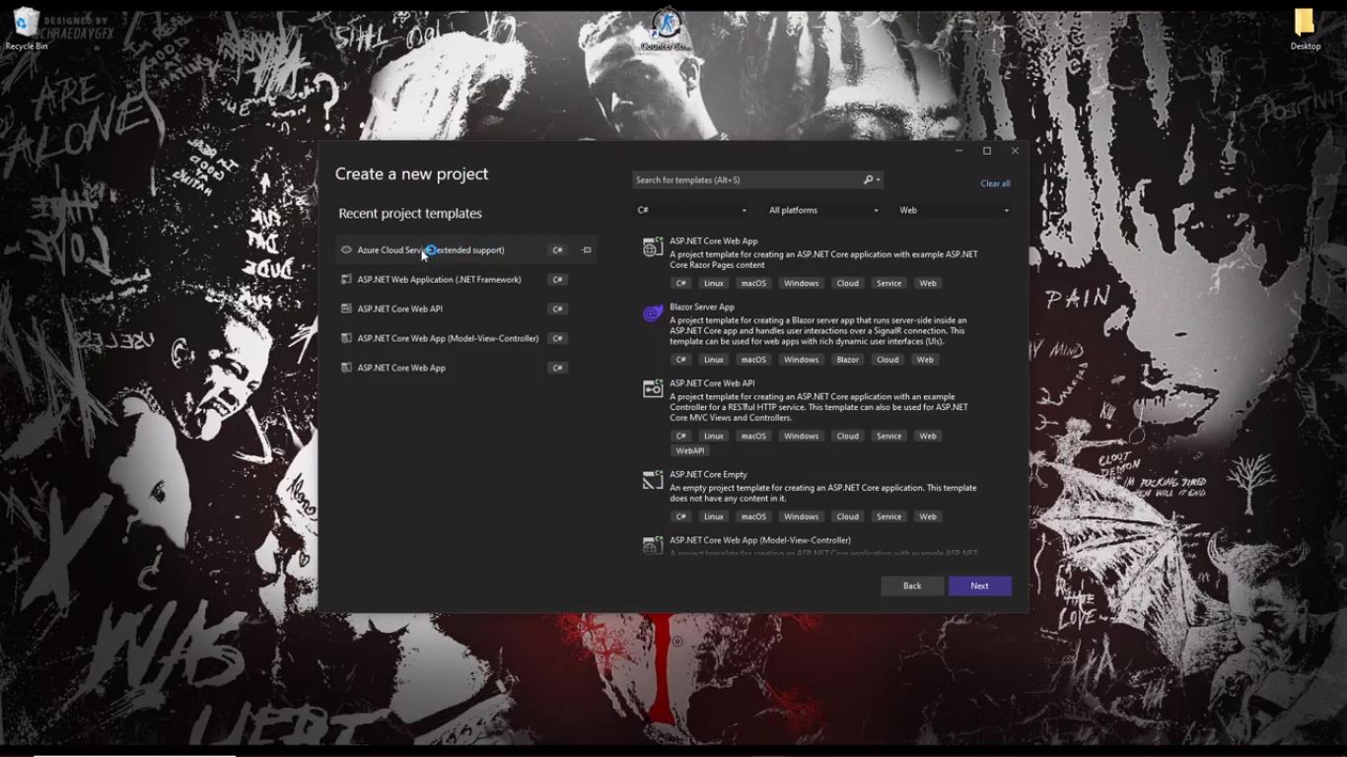

Step 2: Add ‘ASP .NET web role’ to the solution and click ok

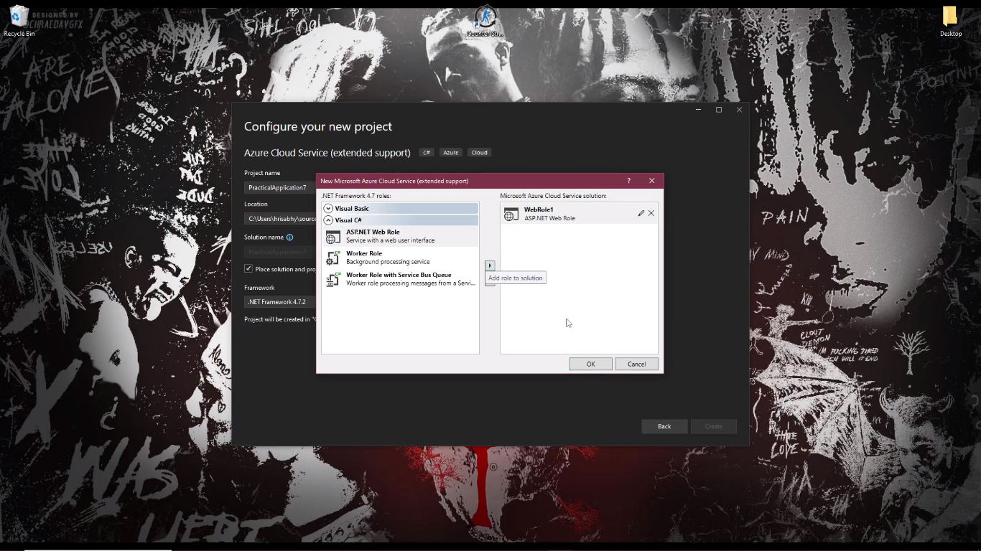

Step 3: Select MVC and click ‘create’.

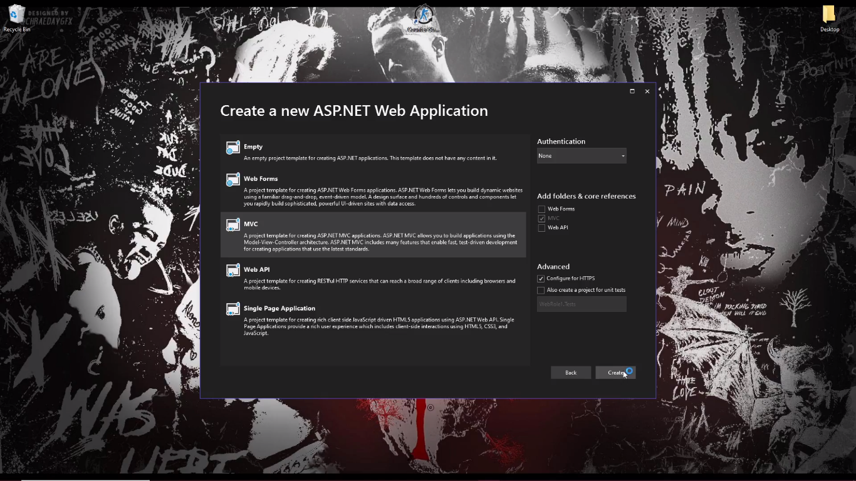

Step 4: Click on _layout.cs.html under ‘shared’ folder under the ‘views’ folder in the solution explorer.

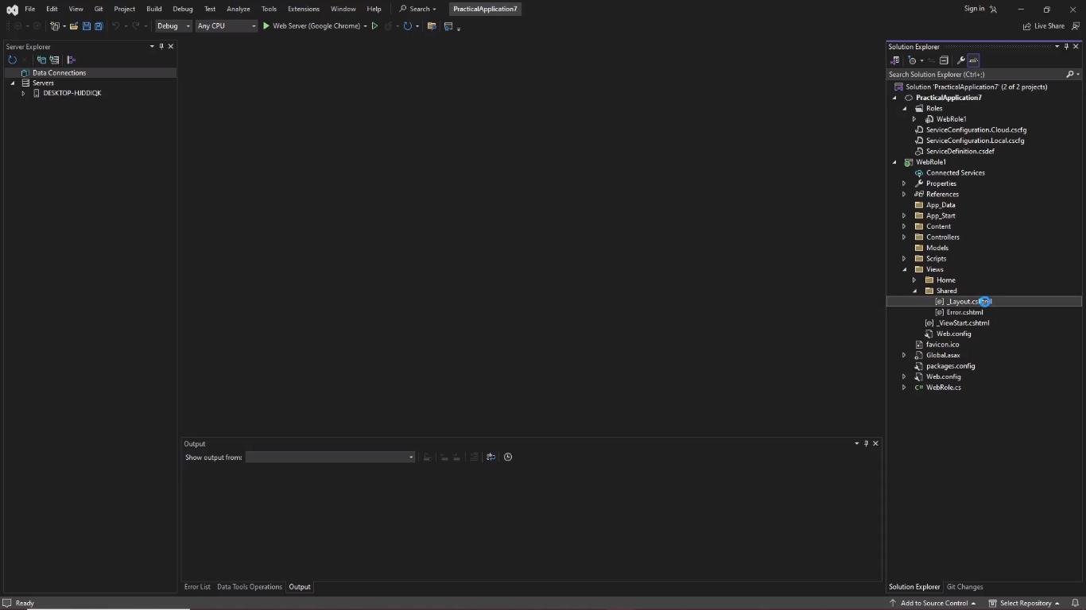

Step 4: Delete the nav class and footer

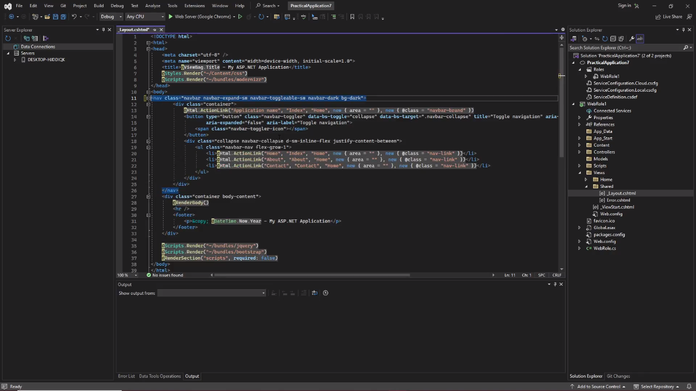

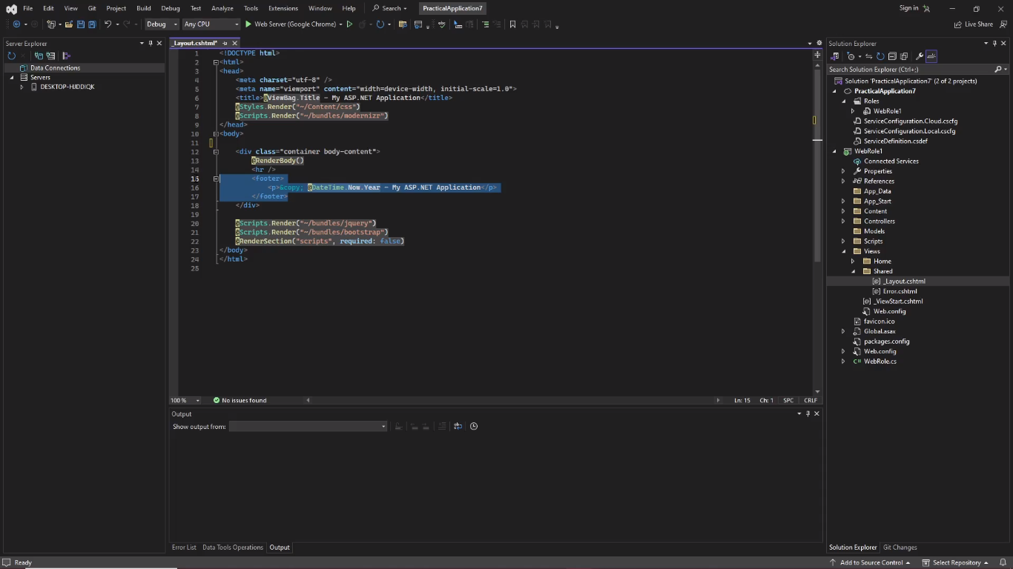

Step 5: got to index.cshtml under ‘home’ folder under ‘views’ folder in solution explorer.

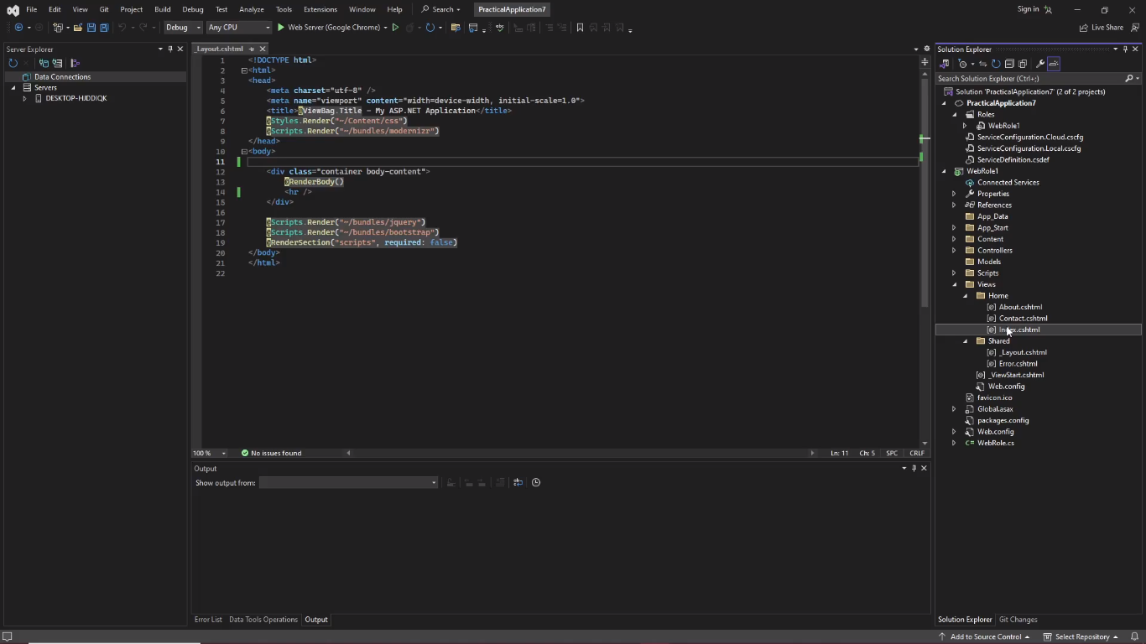

Step 6: Delete the Section class and div class in the main and type Hello world in div.

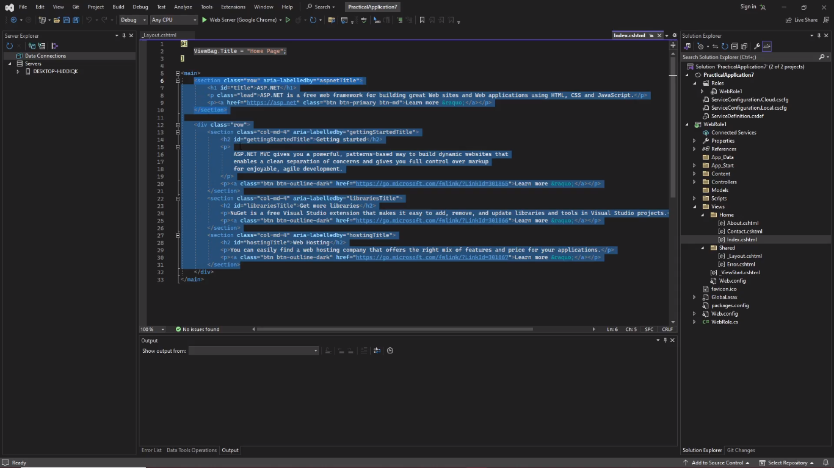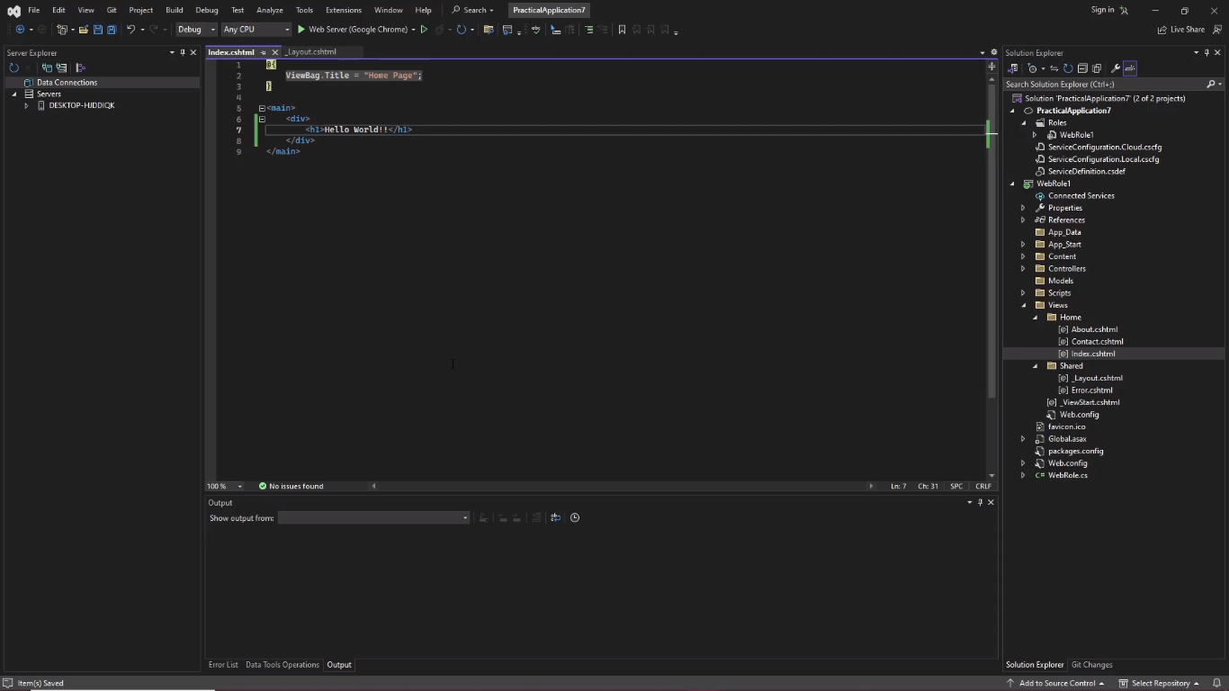

Step 7: Click on the run button/Web server (Google Chrome)

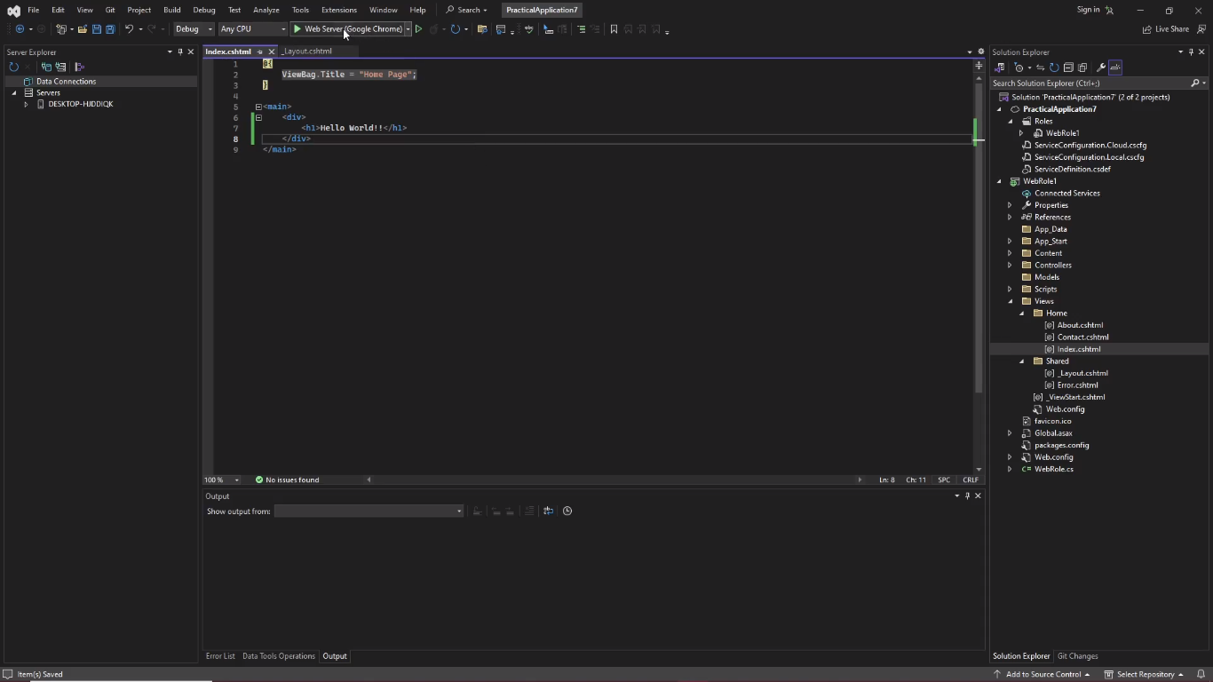

Output:

